Project Overview
The application provided contains multiple vulnerabilities which require mitigation. You are to mitigate each of the vulnerabilities identified in Appendix A of this document. This Project is worth 40% of your overall grade for this module.

Student Output
- You are to mitigate the vulnerabilities and email the updated code to richard.butler@setu.ie by Monday, 30 March 2026. Please email the code files directly as an attachment. Do not mail me a link to your OneDrive repository.
- You are to produce a report outlining your mitigation strategy for each identified vulnerability.
- You will be scheduled for an interview on this project beginning on Monday 13th of April. (schedule to follow)

Your code will be assessed by the lecturer. It is your responsibility to provide functioning code. I suggest you test your mitigated code in the lab before sendin. I will be using the same setup as Lab D426.

Mitigated vulnerabilities will be assessed in an interview as below:
Dimension | High | Pass | Fail
Vulnerability Knowledge | Correctly names, classifies, and explains root cause. | Partially correct description, minor gaps. | Misidentified or unclear.
Mitigation Knowledge | Chooses appropriate control, explains why it mitigates and notes trade-offs. | Gives a plausible fix with limited explanation. | Fix inappropriate or unexplained.

Project Setup:
The application connects to the underlying database using the following user account. You are to setup this “TEST” user account on the database server before the application will create the underlying database. You should have this account already created from already completed lab exercises.
$dbServername = "localhost";
$dbUsername = "TEST";
$dbPassword = "";

- Selected Findings
Date | Attack | Result
11 Feb 2026 | HTTP Type: POST  Location: http://localhost/project26/includes/login.inc.php  Parameter: uid  Payload: <script>alert('XSS Hole')</script> | 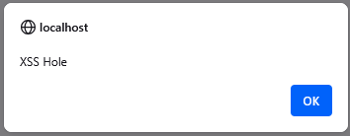  Finding: Reflective XSS
11 Feb 2026 | Before Authentication  Location: http://localhost/project26/index.php  The application sets the following cookie in the browser before Authentication  Cookie: PHPSESSID=sshdi6oc7ji0b8re7goci80156  I then successfully Authenticate as either the ‘admin’ user or as ‘user1’ | The Application successfully authenticates however the Session ID is not updated from an unauthenticated sessionID to an authenticated session ID  The application is authenticated and presents “http://localhost/project26/auth1.php” to the user with the following Session ID:  Cookie: PHPSESSID=sshdi6oc7ji0b8re7goci80156  The PHPSESSID session does not change on successful authentication.  Finding: Session Fixation
11 Feb 2026 | HTTP Type: GET  Location: http://localhost/project26/auth1.php  Parameter: target  Payload: localhost+%26%26+dir | 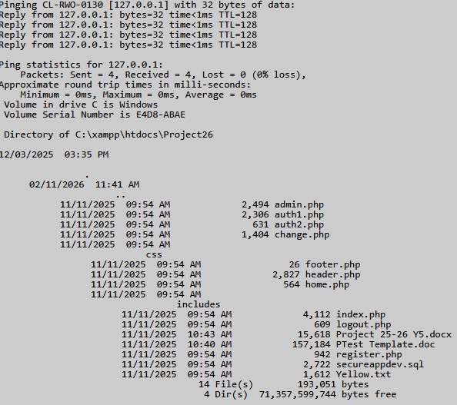  Finding: Command Injection
11 Feb 2026 | HTTP Type: GET  Location: http://localhost/project26/auth2.php  Parameter: FileToView  Payload: ../../../../windows/system32/calc.exe | 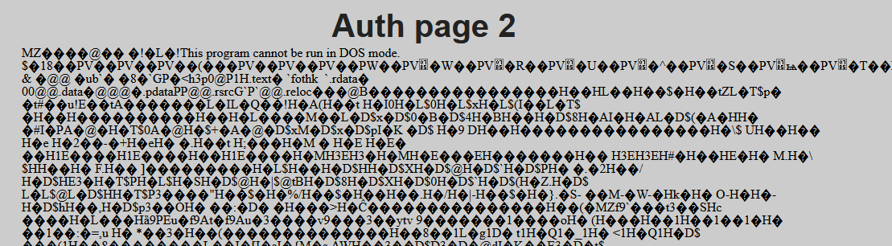  Finding: Directory Traversal
11 Feb 2026 | HTTP Type: GET  Location: http://localhost/project26/admin.php  Parameter:  Payload: | Without Authentication the admin page is directly accessable. This page should only be available to administrator users only  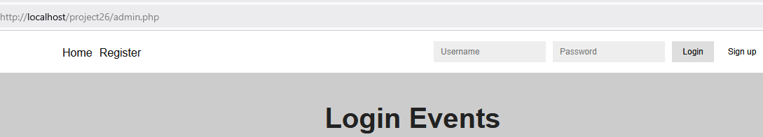  Finding: Insufficent session management (direct page access)
11 Feb 2026 | HTTP Type: POST  Location: http://localhost/project26/includes/login.inc.php  Parameter: uid  Payload: ' onmouseover=alert(1); x=' | Each Authentication attempt is logged and persented in the page: “http://localhost/project26/admin.php”  On a mouserover event on the User ID input box the stored payload execuites.  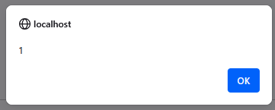  Finding: Persistant XSS
11 Feb 2026 | HTTP Type: POST  Location: http://localhost/project26/includes/signup.inc.php  Parameter: uid=bob&pwd=Password1!&submit= | The application allows for an unlimited number of registration attempts.  The Bute-Force protection that applies to the login functionality should be extended to the registration functionality also.  Finding: Insufficent Brute-Force protection
11 Feb 2026 | HTTP Type: POST  Location: http://localhost/project26/includes/login.inc.php  Parameter: UID  Payload: admin  Parameter: Password  Payload: ' OR Sleep(3); -- | The “Sleep(3)” is successfully executed on the MySQL database as the delay is observed in the page load response. This demonstrates that the underlying SQL query logic has been altered by untrusted unput.  NOTE: The observation that the sleep(3) functions against the password indicates that the passwords of the application are stored insecurely in the database.  Finding: SQL Injection
11 Feb 2026 | HTTP Type: POST  Location: http://localhost/project26/includes/login.inc.php  Parameter: uid  Payload: x' OR Sleep(3) OR ' | The “Sleep(3)” is successfully executed on the MySQL database as the delay is observed in the page load response. This demonstrates that the underlying SQL query logic has been altered by untrusted unput.  Finding: SQL Injection
11 Feb 2026 | HTTP Type: GET  Location:https://localhost/Project25/includes/reset.inc.php  Vulnerable URL:  https://localhost/Project25/includes/reset.inc.php?old=Password2%21&new=Password3%21&new_confirm=Password3%21&reset=yes&csrftoken=c655c81598934e704f5354c9f3e19ebabd088178f28633c43c581e25ebc44b05  The Reset Password functionality is vulnerable to cross-site request forgery (CSRF). | It appears that the CSTF Token is generated OK however, this token appears not ot be validated at the server.  A fake token can be sent with the request such aa in the URL below:  https://localhost/Project25/includes/reset.inc.php?old=Password2%21&new=Password3!&new_confirm=Password3!&reset=yes&csrftoken=--FAKE-Token--  The password provided in the URL must be correct for the exploit to take place.  (NOTE From Richard) I am passing the valuse on the URL in a GET Request to allow for ease of testing. In production all values should be passed in a POST request. I will demo this in the lab.  FINDING: Cross-Site Request Forgery
11 Feb 2026 | HTTP Type: GET & POST  I successfully authenticate with the application and navigate to the different authenticated pages.  I then log out.  In the browser I click the back button and authenticated pages are presented. | Authenticated pages are cached in the browser allowing the user to view authenticated pages without the authenticated functionality available.  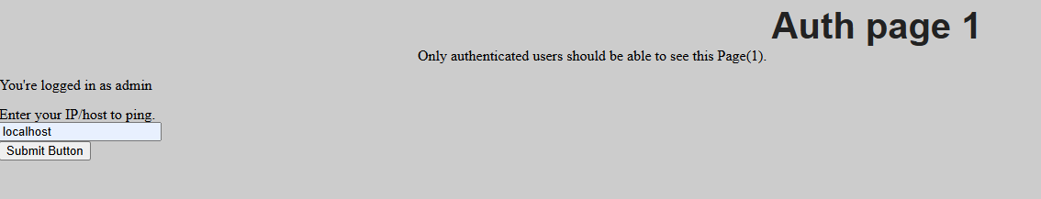  Finding: Page Caching

